**JAVA**

**What is Java ?**

* Object Oriented High level programming language

Object – real world entity



Object Oriented –

It depends on object

High level –

Human understandable format

**History of Java :**

Father of java is **James Gosling**

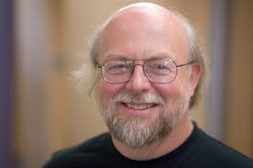

James Gosling and his team members started the project in the early '90s

[James Gosling](https://www.javatpoint.com/james-gosling-father-of-java)**,** initiated the Java language project in June 1991. The small team of sun engineers called **Green Team**.

 Initially it was designed for small, [embedded systems](https://www.javatpoint.com/embedded-system-tutorial) in electronic appliances like set-top boxes.

Firstly, it was called **"Greentalk"** by James Gosling, and the file extension was .gt.

After that, it was called **Oak** and was developed as a part of the Green project.

Oak is a symbol of strength and chosen as a national tree of many countries like the U.S.A., France, Germany, Romania, etc.

In 1995, Oak was renamed as **"Java"**

Java is an island in Indonesia where the first coffee was produced (called Java coffee).

Java name was chosen by James Gosling while having a cup of coffee nearby his office.

JDK 1.0 was released on January 23, 1996.

Oracle corporation is the current owner of JAVA SE platform from the year 2010.

**Simple program**

class Example {

public static void main(String args[]) {

System.out.println(“hello world”);

}

}

Explanation

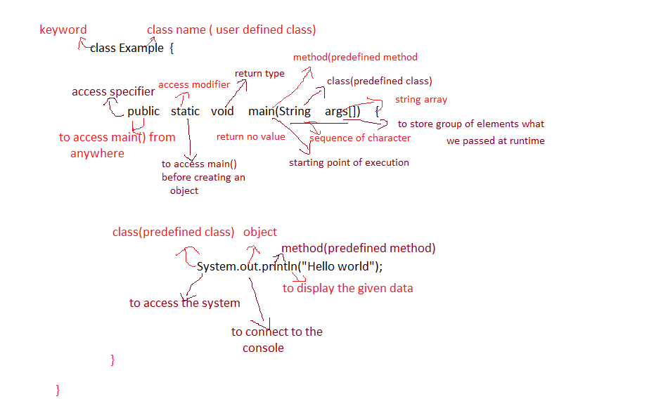

oops

why everybody follow oops

* Because it refers to the real time object.

Dog

**State –**

Name,color, breed,age

**Behaviour** –

Wagging tail, barking, sleeping

IDE (integrated development environment)

Eclipse

**Edition Of Java**

1. **Java Standard Edition (SE)**

Used to develop Desktop Application

1. **Text Editors**:
2. **Media Players**:
3. **Photo Editing Software**:
4. **Java Enterprise Edition (EE)**

Used to develop web and enterprise application

1. **Online Shopping Platform (E-commerce Website)**
2. **Online Banking System**
3. **Java Micro Edition (ME)**

Used to develop mobile application

**developed for smartphones apps using Java (Android)**

**Features of JAVA**

**Object Oriented :**

Everything in a program will be inside of class definition, including main(), it refers to the real time object.

**Platform Independent :**

Write-Once-Run-Anywhere(tuning for different platforms)

Code is compiled to byte code that are interpreted by a Java virtual machine (JVM).

This provides portability to any machine for which a virtual machine has been written.

**Robust**

Exception handling built-in, strong type checking (that is, all data must be declared an

Explicit type), local variables must be initialized.

**Automatic Memory Management**

Automatic garbage collection memory management handled by JVM.

**Multithreading**

Multithreading is a technique that allows a single process split into multiple tasks and

execute concurrently(at the same time and parallel). It is very efficient and light weight process to make maximum use of the CPU, because idle time can be kept to a minimum.

**Built-in Networking**

Java was designed with networking in mind and comes with many classes to develop sophisticated internet communication.

**What is JDK ? (responsible to develop and run the application)**

JDK stands for Java Development Kit. It contains JRE and the development tools such as javac, java etc.

**What is JRE ? ( responsible only to run the application)**

JRE stands for Java Runtime Environment. It is the implementation of JVM. It

Contains set of library files and other files that uses at run time.

**What is JVM ? (responsible to execute the program line by line)**

JVM stands for Java Virtual Machine. It provides runtime environment in which byte

Code can be executed.

**Java Architecture :**

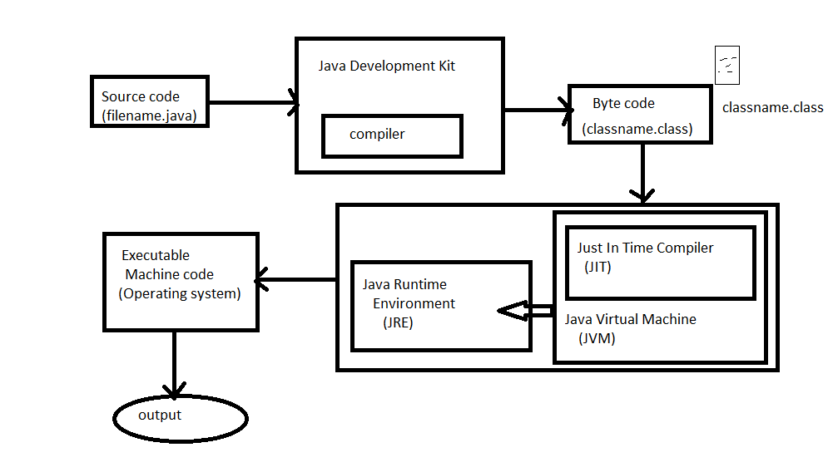

**Priniciple Of OOPS**

**Abstraction**

Complete overview of the particular task

Eg : blueprint

**Encapsulation**

Data hiding

Eg : capsule

**Inheritance**

One object acquiring the properties from another object

Eg : blueprint

**Polymorphism**

Poly – many

Morph – form

One object different forms.

Eg : mobile phone